**C PROGRAMMING ASSIGNMENT:**

**18**

DATE: 07.01.22

SUBMITTED BY: -

NAME: MUKTESH MISHRA

BRANCH: CSE

SECTION: B22

ROLL NO.: 21052258

**1.WAP find sum of first n elements of 2 arrays,**

**return 0(equal sum), 1(1st array sum is larger) or 2(2nd array sum is larger)*/**

***Code:***

#include <stdio.h>

*int* large_sum(*int* \**a*, *int* \**b*,*int* *n*)

{

*int* s1 = 0, s2 = 0;

    for (*int* i = 0; i < *n*; i++)

    {

        s1 += *a*[i];

        s2 += *b*[i];

    }

    printf("Sum of 1st array: %d\n", s1);

    printf("Sum of 2nd array: %d\n", s2);

    if (s1 == s2)

        return 0;

    else if (s1 > s2)

        return 1;

    else

        return 2;

}

*int* main(*int* *argc*, *char* const \**argv*[])

{

*int* x[20], y[20], g,a;

    printf("Specify length of array\n");

    scanf("%d", &a);

    printf("Enter data of 1st array\n");

    for (*int* i = 0; i < a; i++)

    {

        printf("Enter data of array index %d\n ", i);

        scanf("%d", &x[i]);

    }

    printf("Enter data of 2nd array\n");

    for (*int* i = 0; i < a; i++)

    {

        printf("Enter data of array index %d\n ", i);

        scanf("%d", &y[i]);

    }

    g = large_sum(&x,&y,a);

    if (g == 0)

        printf("\nSum of arrays are equal");

    else if (g == 1)

        printf("\nSum of 1st array is more than that of 2nd array");

    else if (g == 2)

        printf("\nSum of 2nd array is more than that of 1st array");

    return 0;

}

***Output:***

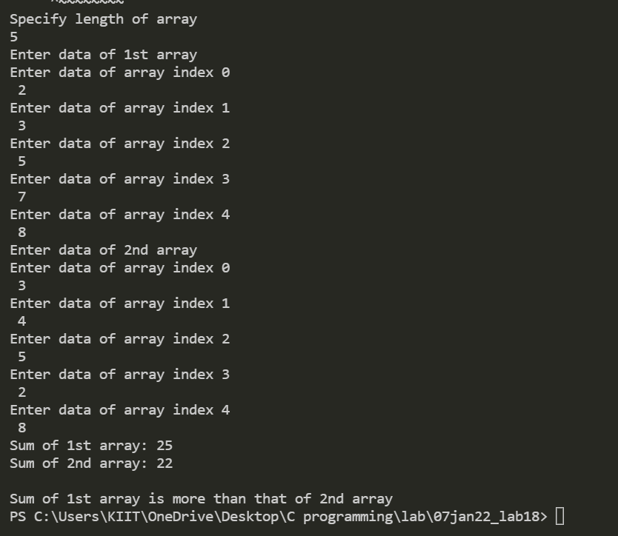

**2. WAP for swapping by call by reference**

***Code:***

#include <stdio.h>

*int* swap(*int* \**a*, *int* \**b*)

{

*int* temp;

   temp = \**b*;

   \**b* = \**a*;

   \**a* = temp;

   return 0;

}

*int* main()

{

*int* x, y;

   printf("Enter the value of x and y\n");

   scanf("%d%d",&x,&y);

   printf("Before Swapping\nx = %d\ny = %d\n", x, y);

   swap(&x, &y);

   printf("After Swapping\nx = %d\ny = %d\n", x, y);

   return 0;

}

***Output:***

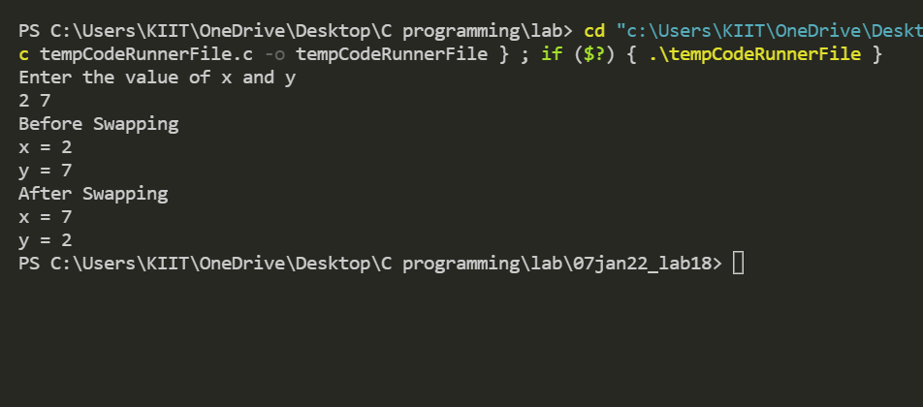

1. **WAP to find factorial by pointers**

***Code:***

#include <stdio.h>

*int* findFactorial(*int* *num*, *int* \**factorial*)

{

*int* i;

    \**factorial* = 1;

    for (i = 1; i <= *num*; i++)

        \**factorial* = \**factorial* * i;

    return 0;

}

*int* main()

{

*int* i, factorial, num;

    printf("Enter a number: ");

    scanf("%d", &num);

    findFactorial(num, &factorial);

    printf("Factorial of %d is: %d", num, factorial);

    return 0;

}

***Output:***

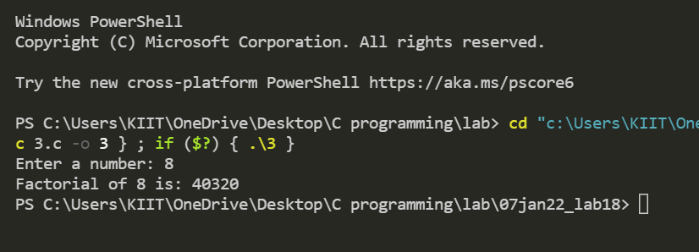

1. **WAP to find palindrome number using call by reference**

***Code:***

#include <stdio.h>

*void* check(*int* *n*, *int* \**p*)

{

*int* r, rev = 0;

    while (*n* > 0)

    {

        r = *n* % 10;

        rev = rev * 10 + r;

*n* = *n* / 10;

    }

    \**p* = rev;

}

*int* main()

{

*int* n, p = 0;

    printf("Enter a number:");

    scanf("%d", &n);

    check(n, &p);

    if (p == n)

    {

        printf("Number is palindrome");

    }

    else

    {

        printf("Number is not palindrome");

    }

    return 0;

}

***Output:***

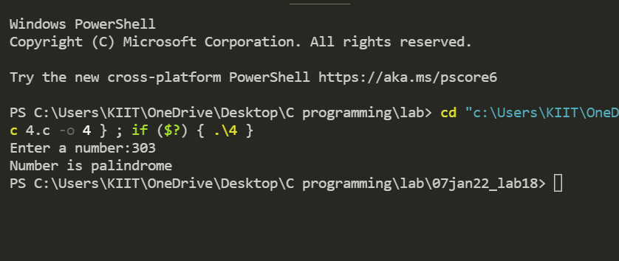

1. **WAP to find number of a's in the given characters array.**

***Code:***

#include <stdio.h>

*int* main()

{

*char* a[] = "Yudhistir", b[] = "Bhim", c[] = "Arjun", d[] = "Nakul", e[] = "Sahadev";

*char* *p[5];

*int* i, j, count = 0;

    p[0] = a;

    p[1] = b;

    p[2] = c;

    p[3] = d;

    p[4] = e;

    for (i = 0; i < 5; i++)

    {

        for (j = 0; p[i][j]; j++)

        {

            count += p[i][j] == 'a';

        }

    }

    printf("\nCount = %d", count);

    return 0;

}

***Output:***

